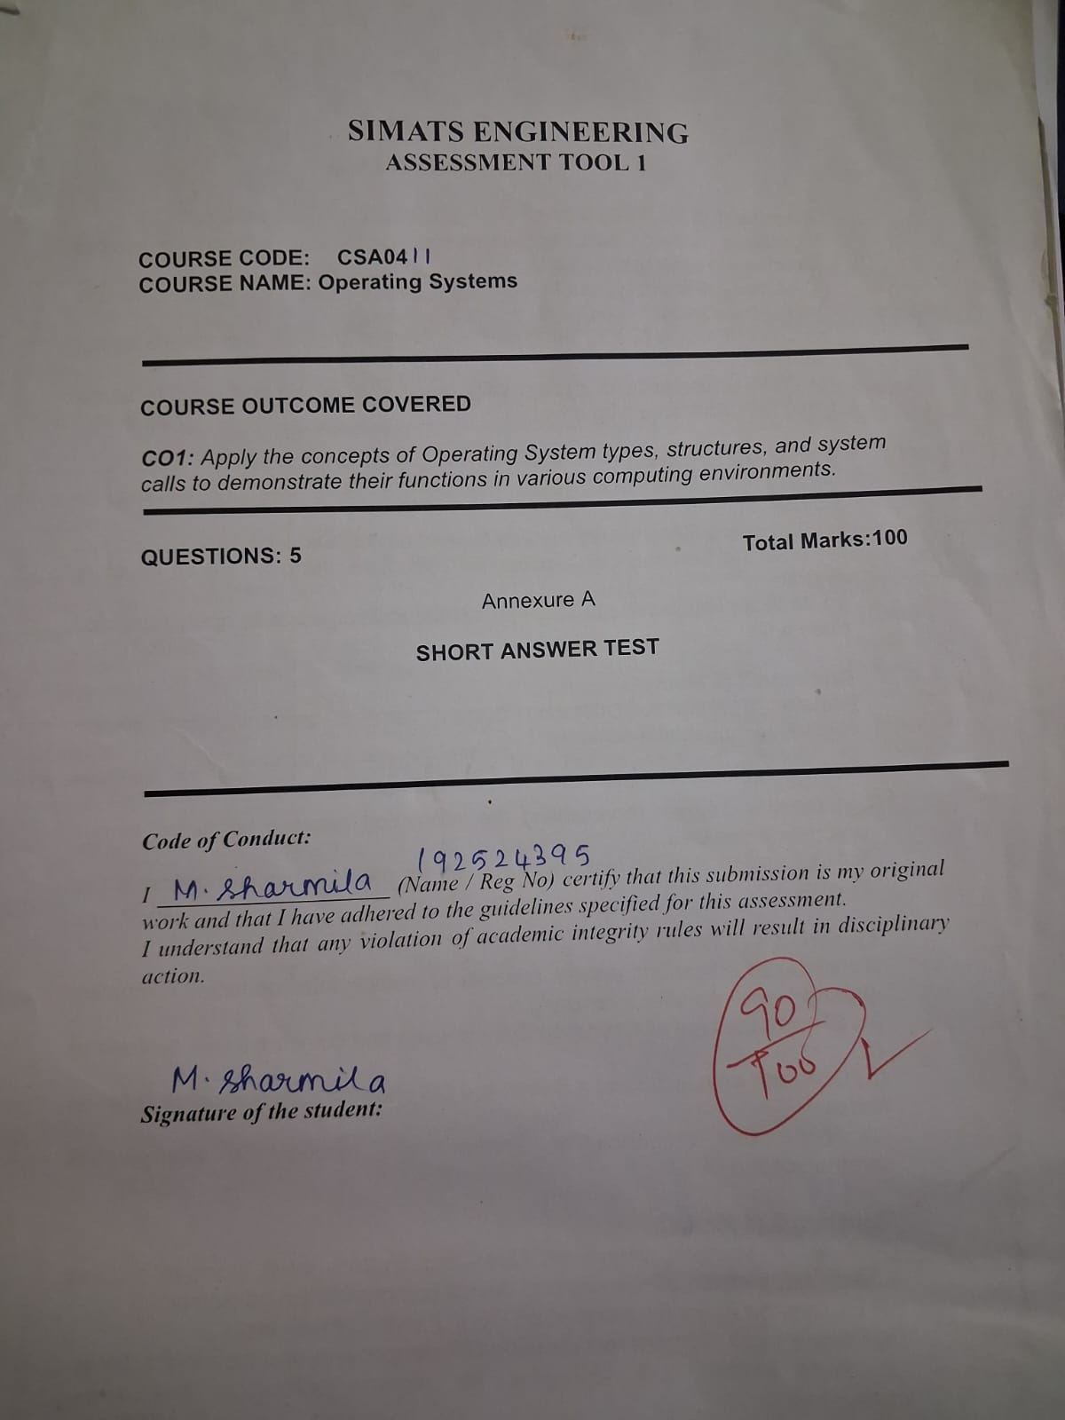

Question 1 (10 Marks)
Suppose a modern Operating System supports multiple users and processes with shared resources like CPU, memory, and I/O devices.
(a) Classify different types of Operating Systems and justify your choice.
- Multi-user OS: Allows multiple users to access the system simultaneously.
- Multitasking OS: Executes multiple tasks by sharing CPU time.
- Multiprocessing OS: Uses multiple CPUs or cores to execute processes.
- Time-sharing OS: Allocates CPU time to different users and processes.
- Distributed OS: Manages resources across multiple connected computers.
- Batch OS: Executes jobs in batches without continuous user interaction.
Justification: A modern multi-user system mainly uses multitasking, multiprocessing, and time-sharing to manage shared resources efficiently.
(b) Draw the structure of an Operating System.
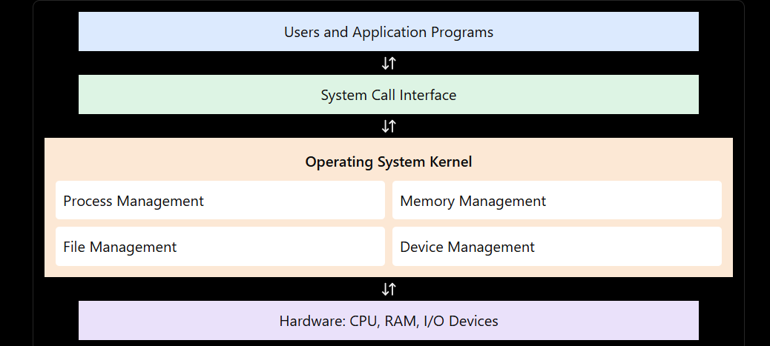
Explanation: The OS acts as an interface between applications and hardware. The kernel manages processes, memory, files, and devices.
(c) Write the sequence of system calls required to create and execute a new process.
- fork() – Creates a child process.
- exec() – Loads and executes a new program.
- wait() – Makes the parent wait for the child.
- exit() – Terminates the process.
Example in C:
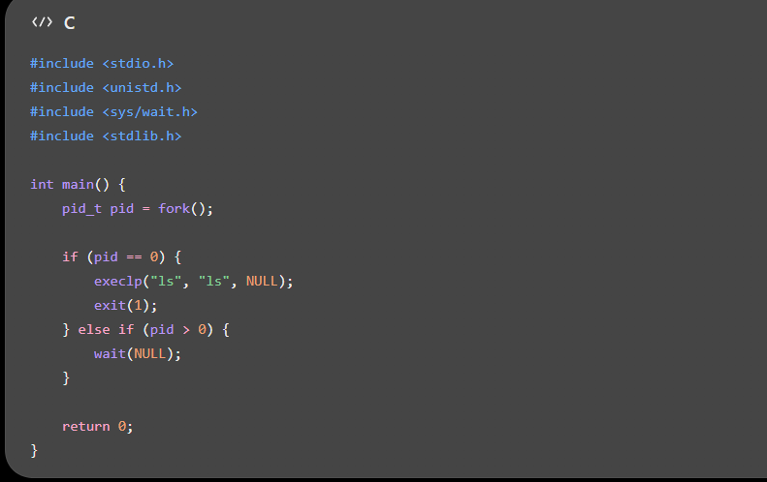
Question 2 (10 Marks)
Consider an Operating System managing multiple files and devices for concurrent users.
(a) Categorize system calls used for file and device management.
1. File management
- open() – Opens a file.
- read() – Reads file data.
- write() – Writes file data.
- close() – Closes a file.
- unlink() – Removes a file.
2. Device management
- open() – Opens a device.
- read() – Reads device data.
- write() – Writes device data.
- ioctl() – Controls device-specific operations.
3. Protection
- chmod() – Changes file permissions.
- access() – Checks access permissions.
(b) Illustrate the layered structure of file operations.
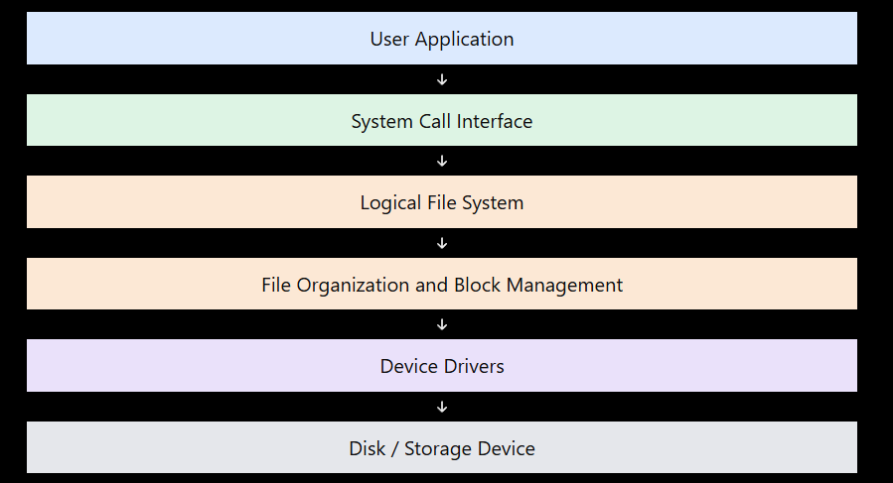
Explanation: The application requests file operations through system calls. The file system locates and manages data, and device drivers communicate with the storage hardware.
(c) Write a C program to open, read, and close a file.
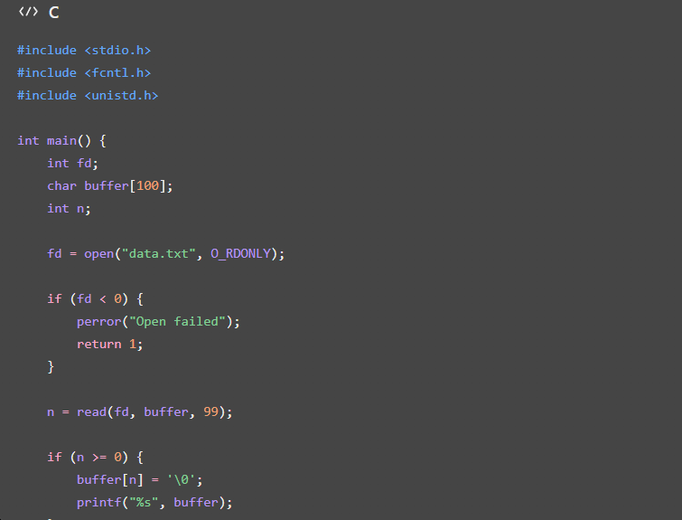
Output: Displays the contents of data.txt, if the file opens and reads successfully.
Question 3 (10 Marks)
Assume a real-time Operating System is used in an embedded system controlling industrial machinery.
(a) Identify the type of OS and explain why it is suitable.
A Real-Time Operating System (RTOS) processes tasks within specified time limits.
Types:
- Hard RTOS: Deadlines must not be missed, such as in emergency shutdown systems.
- Soft RTOS: Occasional deadline misses are acceptable, such as in multimedia applications.
Advantages:
- Fast response to events.
- Predictable scheduling.
- Efficient interrupt handling.
- Reliable task execution.
- Supports process synchronization.
(b) Draw the interaction between hardware, kernel, and user processes.
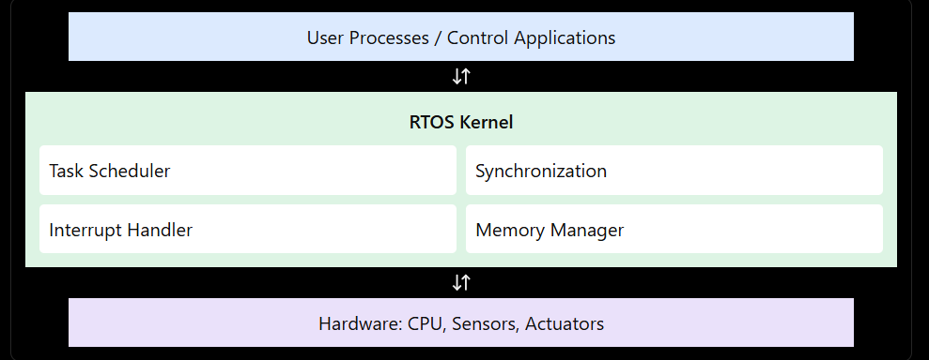
Explanation: The kernel schedules tasks, handles interrupts, and coordinates communication between control applications and hardware.
(c) List and explain system calls used for process synchronization.
- sem_wait() – Waits until a semaphore is available.
- sem_post() – Releases a semaphore.
- pthread_mutex_lock() – Locks shared resources.
- pthread_mutex_unlock() – Releases a mutex.
- pthread_cond_wait() – Waits for a specified condition.
- pthread_cond_signal() – Wakes a waiting thread.
Importance: These synchronization functions prevent race conditions and ensure safe access to shared resources. They are POSIX APIs commonly used in RTOS-based applications.
Question 4 (10 Marks)
A distributed computing system consists of multiple interconnected computers sharing resources over a network.
(a) Classify the OS and compare it with a centralized OS.
A Distributed Operating System manages multiple connected computers and enables resource sharing through a network.
Distributed OS | Centralized OS
Uses multiple interconnected computers. | Uses a central computer.
Resources are distributed among nodes. | Resources are managed centrally.
Supports scalability. | Expansion may depend on central capacity.
Can tolerate some node failures. | Central failure may affect the entire system.
Communication occurs over a network. | Communication mainly uses the central system.
Advantages: Resource sharing, scalability, improved workload distribution, and potential fault tolerance.
(b) Draw the architecture of a distributed OS.
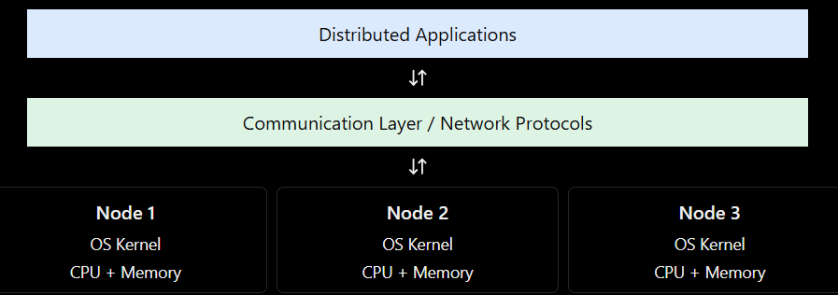
Explanation: Each node has its own processing and memory resources. The network allows nodes to exchange messages and share resources.
(c) Write the sequence of system calls involved in IPC.
For connection-oriented communication using sockets:
- socket() – Creates a socket.
- bind() – Assigns an address to the server socket.
- listen() – Waits for connection requests.
- accept() – Accepts a client connection.
- connect() – Connects the client to the server.
- send() / recv() – Transfers data between processes.
- close() – Closes the socket.
Use: IPC enables processes on different computers to communicate and share information.
Question 5 (10 Marks)
Consider an Operating System that must manage process scheduling, memory allocation, and device communication efficiently.
(a) Explain the major functions of an OS.
- Process management: Creates, schedules, synchronizes, and terminates processes.
- Memory management: Allocates and releases memory and manages virtual memory.
- Device management: Controls I/O devices through device drivers.
- File management: Creates, reads, writes, and deletes files.
- Security and protection: Prevents unauthorized access.
- Resource allocation: Distributes CPU time, memory, and devices.
- Error handling: Detects and handles system errors.
- User interface: Provides a command-line or graphical interface.
(b) Draw a block diagram representing OS components and their interactions.
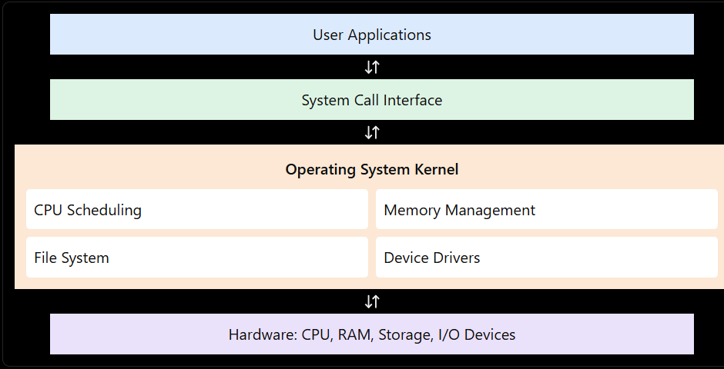
Explanation: Applications request services through system calls. The kernel manages resources and communicates with hardware.
(c) Write system call examples for memory allocation and device management.
Memory management:
- mmap() – Maps memory into a process.
- munmap() – Releases mapped memory.
- brk() – Changes the process's data-segment boundary.
Device management:
- open() – Opens a device file.
- read() – Reads device data.
- write() – Writes device data.
- ioctl() – Performs device-specific control operations.
Example:
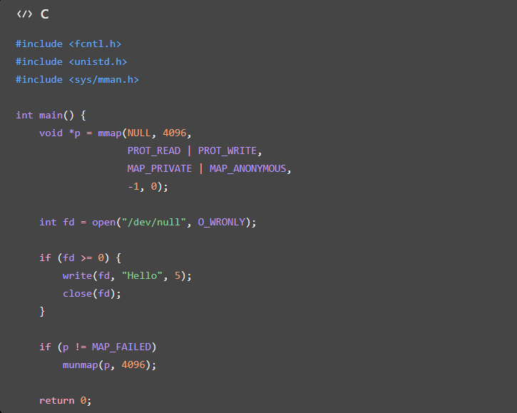

Conclusion: The OS manages CPU scheduling, memory, files, and devices to ensure efficient and reliable system operation.
